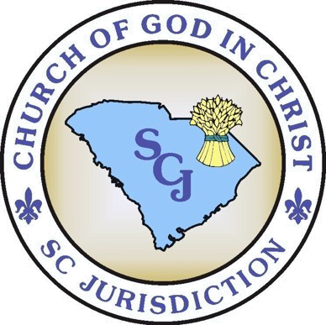
Administrative Assistants William A. Prioleau
Alonzo Johnson

Jurisdictional Supervisor Mother Willie Mae Rivers
Jurisdictional Secretary
Edward L. Johnson
Satellite Office
843.797.5418 Fax 843.572.9577 P O Box 117
Goose Creek, SC 29445
Headquarters
803.516.0102 fax 803.535.3461
www.scjcogic.org

CHURCH OF GOD IN CHRIST SOUTH CAROLINA JURISDICTION
BISHOP JOHNIE JAMES JOHNSON, PRELATE

M E M O

TO: Superintendents, District Missionaries, & Executive Board

FROM: Bishop Johnie J. Johnson, Prelate

DATE: May 31, 2019

RE: Monthly Leadership Conference Call

Leaders, I am thankful to the Lord for his blessings and allowing me to join you in planning for another TRIAD Convention & Holy Convocation. As we prepare for the meeting, we need you to be present on the Monthly Leadership Call on Monday, June 3rd at 9:00 p.m . I have asked the Administrative Assistants, along with other Departmental heads and Executive Committee members, to prepare to share with you the items that are listed below. Your involvement is important, as it will also give us time to share some things with you prior to our Preparational Conference on June 8th at 10:00 a.m. The Call in Number is:
(712) 770-5505, the Code is: 140903.

Topics for Discussion:

- “MORE LORD”: The Bishop’s Monday Holy Convocation Solemn Assembly for All Leaders & Delegates. Monday: 10:00 a.m. to 1:30 p.m.
- Saints in the Marketplace: Monday: 10:00 a.m. to 1:30 p.m.
- The District Nights for TRIAD
- The line-up of speakers activities for the Evening Worship.
- The Day Schedule for the week:
- The Charities & Emergency Relief Luncheon: Thursday Afternoon
- The J.W. Wilson Institute
Schedule, Topics, Presenters
- Budget & Finance Matters for the Holy Convocation: Registration, District Boosters, In-Office Love Offerings for the Leaders, Official Night Love Offerings

